“Four ‘Head Gardeners’ in the Andes”
Travel adventure exploring the
‘Chilean National Parks’
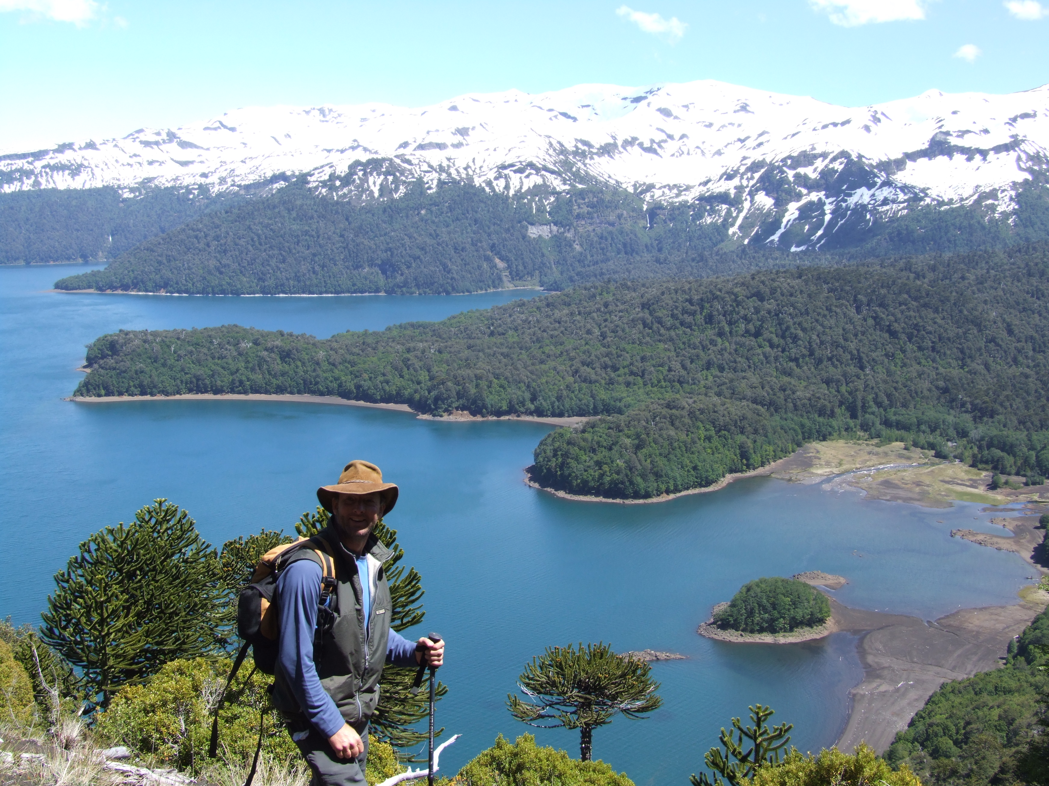

A presentation by Stephen Griffith
(Curator at Abbotsbury Subtropical gardens)

Friday 14th March, 7.30pm at
Burton Bradstock Village Hall, tickets on the door

I am running the London Marathon
All proceeds in aid of

The Stroke Association

